* Design and implement Google App Engine application to Add and find a product of two Numbers.
* **Steps:**
* Download Eclipse IDE for Enterprise Java Developers and Install.
* Open Eclipse and Choose your workspace and click on it.
* 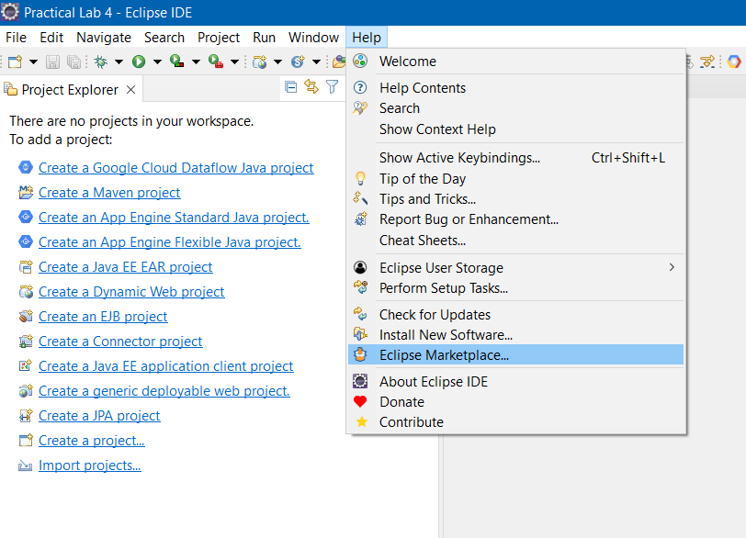Click on >>**Help**>>**Eclipse Marketplace.**
* In Find Search Box: Search for “**Google cloud tools for eclipse**” and click on the Install button. After complete installation of the plugin restart the Eclipse.

* Graphical user interface, application

  Description automatically generatedGraphical user interface, text, application, email

  Description automatically generatedClick on the ‘File’ menu and select >>**New**>>**Other** and search with the “**Google**” keyword and select Google App Engine Standard Java Project under Google Cloud Platform and click on Next
* Enter Project Name “**GoogleAppEngine_WebService**” and Package Name “**com.gae.webservice**” and then Click on >>**Next** >> **Finish**.

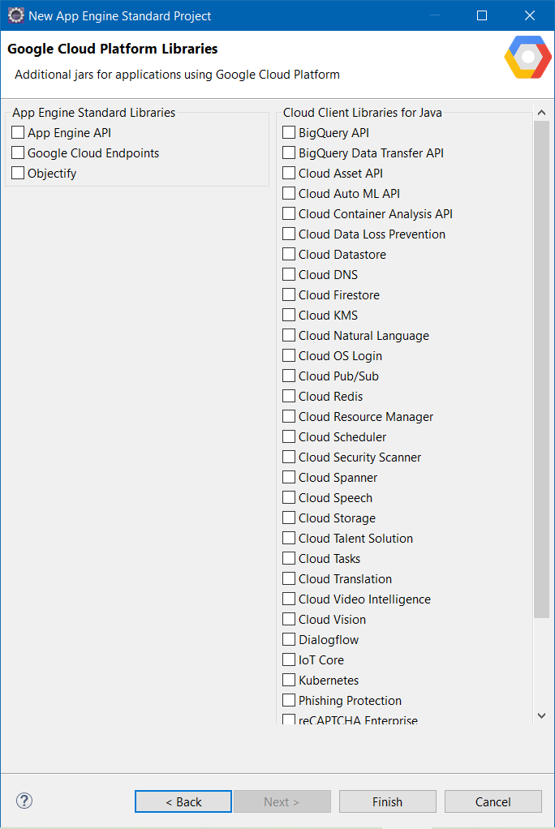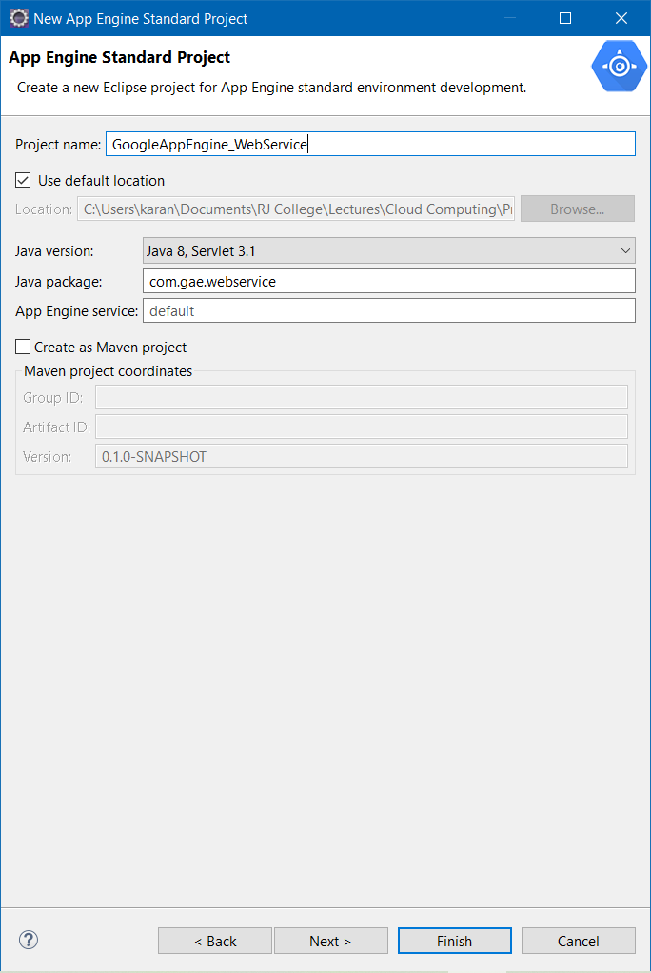

* Open project hierarchy.
* Edit the file as required (Unedited file too can be used. Here the editing is done to “what should be displayed” on the browser). Save the file.

**index.html**

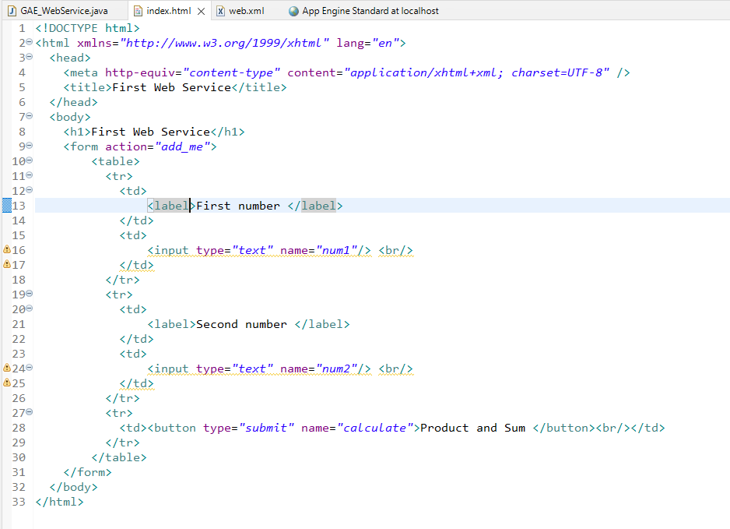

**GAE_WebService.java**

**Web.xml**

* Configuring “App Engine Standard” Server. Click on the link to create a new server under Server tab.

* Start the “App Engine Standard” server.

**Output:**

